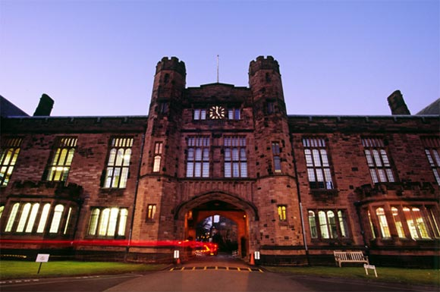

Sofna College: Pressure to Change

It was 9:00 pm and Jan Walker reflected on her recent decision to become Head of Sofna College and on her assessment of the school’s challenges. Tomorrow would be her first day on the job and there was a great deal to do.

Walker knew that Sofna College was badly in need of change. The school was facing a host of problems many of which organizational members did not, or were not willing, to recognize. For Walker, it was disappointing to see a school with such a proud past be faced with such a troubled future.

Now she had taken on the challenge of turning around Sofna College’s poor financial and academic performance. The question was, as the new Head hired from outside the organization, how to get started and what to do first?

The Story of Sofna

Sofna College was founded in 1923 by Samuel Stark MBE, Dr. Eleye Fearnley Hvas and Hilda Berents as an independent school to educate young men. They established a high school for 36 pupils, primarily the children of diplomats and businessmen residing in the Capital area. Mr. Stark was the first Headmaster and remained so until his retirement in 1939.  Dr. Hyas provided the College with a large parcel of land on the outskirts of the city and also the funds to build the first school and the student residence. The College still occupies the same grounds today.

During the 1940’s the school grew to an enrolment of about 180 pupils, including two small classes for students aged between 11 and 14 years. During this time two other buildings were developed to provide housing for faculty and staff as well as the Headmasters house appropriately named for the school’s first benefactor, the Hyas House.

In 1947, the College embarked on a process leading to accreditation with the *National Council of International Schools*. The quality assurance mechanism which was comprehensive, rigorous and ongoing was awarded in 1948 and is still held by Sofna College today.

In the 1950’s the development of the Capital area brought many families to region. During this time enrolment rose to around 280 students and was increasing steadily. It was a time of prosperity for the College with new sports fields being developed, additional buildings including a science centre, a new gymnasium and additional academic classrooms and residential space being constructed. During this time Sofna built upon its founding roots and became the chosen academic home for most of the senior diplomat’s families in the Capital area, for the son’s of politicians and for the wealthy business families too. It was seen as a truly international school that prepared students to understand the challenges of a growingly more important global community.

The 1960’s and 70’s were for the College, very much like the times. There were periods of ebb and flux, unrest and questioning but generally the College did well. In 1974, when one of its graduates became the Foreign Minister for the country there was reason to celebrate and the College did just that. At times, from an outsider’s perspectives, the College might have appeared to be doing a little too much celebrating. The perception was that the focus was moving towards extra-curricular activities and less attention was being paid to the academic side of the house. But, budgets were always balanced and often finances were added to the growing reserves of the school.

In the summer of 1986 a new Head of School was appointed from outside of the School. This appointment did not work out and following a further search process Dr. Carman Carlson was appointed as the Head of the School in May 1987. An energetic and visionary individual he stepped into the position and forged new directions for the College. Growth in programs included the addition of the primary school occurred almost immediately after Carlson came on board (now the College curriculum covered from K-12). With the additional students there was a need for new buildings to house this growth. Internal funds were found to start this and a very successful capital campaign was launched and quickly surpassed its goal. The administrative side of the college also received attention. The school was organized into three sections, each with a Principal.

In the early 1990’s, Sofna College found themselves land locked by the City that now surrounded them and also as a result of their active building program. There was little room left for further growth. At this time, Carlson was also seriously considering expanding into co-educational programs but with little space to develop this idea he was unable to pursue this option. In 1994, the closure of a smaller independent school provided Sofna the opportunity to obtain land and two buildings that were relatively close to the main campus area; this provided the College with room for expansion. As a result, Carlson went to the Board of Trustees to seek approval for the borrowing of capital to facilitate this expansion – the first time Sofna had financed a project externally.

Soon after obtaining the land, Carlson talked the Board into approving a controversial co-ed program which was then launched in 1996. It was an immediate financial success with an additional 121 girls and young women joining the College bringing the total number of student up to 545. However, a number of families chose to take their sons out of the College to another independent, boys only school. This left a tear in the community that still exists today. With this expansion, one other result was that the College was split across two sites with the Infants/Lower Primary occupying the newly acquired site. The physical distance resulted in a growing emotional distance between the Upper and Lower schools; this is still apparent today.

In 1998 a new wing was added to the central building on the main campus. Then, in the summer of 2001, the Infants/Lower Primary program was moved into temporary classrooms on the satellite site following a series of problems with their building. In response, Carlson undertook a comprehensive program of refurbishment in three phases, finishing in April 2004. This provided improved specialist rooms, more flexibility and permanent accommodation for classes previously held in temporary classrooms. The last of the temporary buildings was removed when the Primary moved into a new building in January 2005.

In the summer of 2009, Dr. Carlson announced that he was stepping down as Head after 23 years in the role.

The Difficult Path Ahead

Initially, from an outsider’s perspective, it would appear that all is well at Sofna College – but it didn’t take too long after Walker scratched the surface to see that all was not. While there appeared to be an aura of action in the College, little had been done to bring the school into the 21st century. And, it was starting to show.

The retiring Head master was well-liked. He had made some significant positive changes to the College early in his career but had largely positioned himself in a caretaker role for the last 5 years. While there appeared to be tensions below the surface, the Head had full staff, faculty and alumnae support and, as important, their respect. While it was widely rumored that there was disparaging talk around the water cooler on a host of matters, no public discourse had taken place; interesting to Walker, the Board did not share any concerns with her even after she was hired.

When looking at enrollment, Walker noticed that the number of students enrolled at the College now stands at 412. An analysis over the last five years showed the College shrinking by 10 students annually. There is one class for each of the K-4 age groups with 2-3 sections in each of the 5 – 12 classes. Grade 7 and 9 appear to be slightly larger but there is a small grade 10 class. Boarding school numbers are presently at 50 and also in decline, about two per year.

Tuition is set at 22K across the board with a fee increase of 3% proposed. A private, internal memo from the Director of Finance suggests that the Board look at bringing in discounts for the Infant/Primary students thereby enacting a progressive fee strategy (starting at 15K). As well, the College had implemented a financial assistance program for approximately 25 students a year – for a variety of reasons, these students had anywhere from a 50% to 75% scholarship awarded.

When looking at the Board of Trustees, it appears that this is a mature group as there has been little turn over in the last 10 years. A review of minutes shows that on average, just over half of the Board members show up for meetings although no one has missed enough meetings, according to the bylaws, to be removed. In general, they are highly regarded members of the community and all support the College financially, although the level of giving is fairly low.

Strategically, it is highlighted on the College web page that the mission, vision and values have not been updated since 1996 (see Appendix 1) and the last major academic review was held in 1999. Walker was surprised that several of the recent ministry recommendations had not been implemented and the level of faculty engagement, to her as an outsider, has seemed rather low; although no documentation exists to confirm that. As well, Sofna College “Rekkrs” had enjoyed a number of years of relatively successful athletic accomplishments and the College is widely seen as an athletic school but, of late, the school had not won a championship for several years.

Financially, debt is a concern. The building boom of the 1990s and early 2000s, and the reliance on debt to finance this growth, has resulted in a strain on the bottom line. In reading the financial statements, Walker has found that the College has been in a deficit position the last three years; it has had to dip into investment revenue to meet its financial obligations (the endowment gap – between revenue and expenditure made up with endowment money is now at 22%). And, thanks to the mortgage crises south of the border, endowment incomes are now much smaller than their former levels. Insurance, heating and maintenance costs are also rising. At least the boarding costs are covered by the boarding fees. To lessen the challenge to the bottom line, several staff vacancies have been left unfilled. Fewer hands are now asked to do more work.

Looking at the Faculty report put together by the HR Director, it appears that the College has a fairly senior group of teachers with correspondingly senior salaries. With tight budgets, little external professional training has been held. The College is a union environment and the next round of bargaining is set to start this fall as the contract expires in the spring. Overall, there is a collegial relationship across the faculty which extended into the Headmaster’s office when Carlson was at the helm.

The senior management team includes the Primary Principal Derek J. Hall, Lower Secondary Principal Joan Town with Lesley Luitjens being the Upper Secondary Principal. Tom Agent is the Director of Finance and Susan Summers the Director of Advancement. All have been with the College for the past five years.

There was an unsuccessful capital campaign 3 years ago – the level of alumni support – both percentage contributions and in total revenue raised, were far below the Millennium Campaign held previously. However, there was one bright spot – a major gift was given by a distinguished alumnus that was the College’s largest since its inception. Alumnae regular events have been reasonably attended and are seen as being successful “friend-raising” sessions. Walker has also been told that the Director of Advancement is thinking of retiring.

Getting Started

Today, Jan Walker, the outsider with solid experience at another independent school, ponders the possibilities and the challenges ahead. There are many strategic paths possible – however, what concerns her is twofold: what to do and what is the best way to implement them? Walker needs to determine what she should do on her first day at Sofna College, during her first week, and in his first few months. What are his priorities and how should he go about making change happened? What messages should she send, and to whom? And, specifically, what should she do tomorrow?

Appendix 1

**Our Vision**  
To develop the unique potential of every student.

**Our Mission**Sofna College offers a challenging international education.

**Our Values**

**Our students will be:**• Included in a stimulating and caring environment.  
• Independent learners, active in their approach to their own learning.  
• Challenged to develop the essential knowledge, skills and attitudes.  
• Stimulated by a quality education and rigorous assessment.  
• Nurtured by caring, qualified teachers to be happy, successful people.  
• Ethical international citizens of a changing and challenging world.

**Our teaching and support staff will:**• Promote and support intellectual growth and excellence in all aspects of learning  
• Foster a passion for learning  
• Make learning relevant, rigorous and real  
• Utilise the most appropriate technology and resources available  
• Be actively involved in professional development

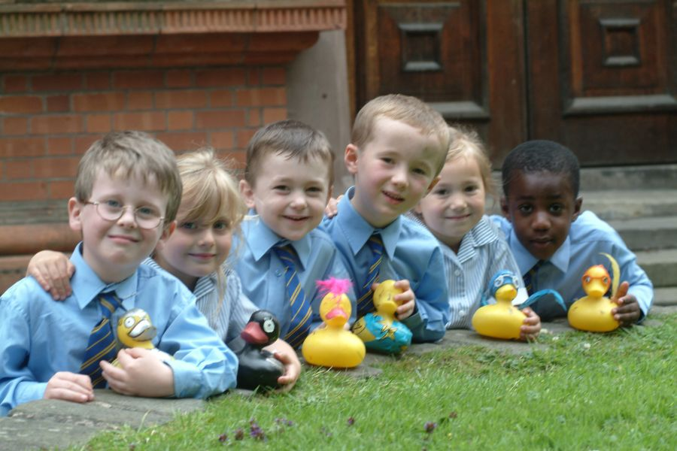

[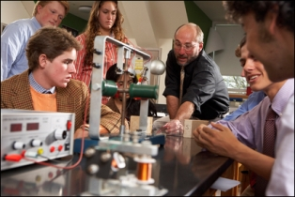](http://www.mytorontoprivateschool.com/private-school-preschool-boys-boarding-religious.htm/toronto-private-school-2/)