Team Niagara | 
Business Friendly Niagara
Date | Services Performed By: | Services Performed For:
November 26, 2015 | Team Niagara  500 Glenridge Ave.  St. Catharines, ON L2S 3A1 | Niagara Community Observatory  500 Glenridge Ave.  St. Catharines, ON L2S 3A1

Niagara Region: Facts and Numbers
Ontario’s Open for Business Act seeks to create sustainable economic development by fostering simpler, better, and faster interactions between government and businesses. Through this initiative, the Ontario government explicitly signifies the importance of growing the economy by creating a strong, dynamic business climate across the province. In consonance with these ambitions, the Niagara Region’s 2015 Council Business Plan indicates that a primary goal of the region is to “become a prime destination for investment and encourage the growth of a diversified and sustainable economic base” (Burroughs, 2015, p. 1).
In spite of the Niagara region’s stated commitment to improve economic prosperity in the region and develop businesses, in 2014, Niagara had the highest unemployment rate in Ontario at 8.8 percent (Radwanski, 2015). The region has clearly failed to bounce back after the dramatic 38.5% decline in the manufacturing industry between 2001 and 2009, in which 14,000 jobs were lost. Since the loss of many of the major manufacturing industries, the region’s employment growth has been less than 1% over the past 10 years (in comparison to Ontario’s average growth rate of 17.5%) and the median income is the lowest of the 11 metropolitan areas in Ontario (Industry Niagara, 2014). For these reasons and more, Money Sense magazine’s recent list of 201 Canadian cities ranked from best to worst places to live placed St. Catharines at 134th, Niagara Falls at 168th, and Welland near the bottom of the list at 180th (Brown, 2014).
Problem Statement: What is “Business-Friendly”?
As noted, although the Niagara region claims to be “Open for Business,” it does not meet the many of its own criteria, including generating economic growth or acting as a prime destination for investment. The lack of new investment in the region and the substantial difficulties local businesses are facing during attempts for growth are causing a significant loss of the area’s local young talents.
Our team will work on providing a consulting report to discern the explicit connotations and criteria of a “business friendly” society and analyse how to make the Niagara region appropriately business friendly.
We believe that the region will continue to see problems until detailed dimensions of “business friendly” are clearly defined and accepted by the region policy maker. Through these distinctly stated delineations, the region will finally establish a means to make itself more attractive to businesses. With more business coming to the region, more young professionals will come and form a virtuous circle of a prosperous region.
Relevant Theories: Understanding “Business Friendly”
Timeliness
One factor that the team should consider when choosing a solution is timeliness. Timeliness offers a useful approach in the evaluation of alternatives, as it assesses how fast the alternative can be implemented and a positive impact can be achieved (Schermerhorn & Wright, 2014).
Performance efficiency
In addition, the team should consider performance efficiency when selecing a solution. The performance efficiency theory outlines the attempt to accomplish a task with the least waste possible. Specifically, perfomance efficiency involves operating competently while exerting the least possible amount of time and effort (Schermerhorn & Wright, 2014).
Useful information
The team should also consider the required characteristics for useful information prior to making a final decision. Notably, data is not necessarily information. Rather, data are raw facts which only qualify as being “information” when the data is useful and meaningful to the overall decision-making process (Schermerhorn & Wright, 2014). It is therefore important to remember to consider whether or not any collected data will be appropraitely high quality, complete, relevant, and understandable.
Benchmarking
Finally, the team should make a decision while considering the theory of benchmarking. Benchmarking is the act of identifying competencies in external and internal zones of comparison and planning on how to incorporate these ideas into one’s own operations (Schermerhorn & Wright, 2014).
Alternatives
Survey
One possible solution to the problem is to conduct an online survey evaluating local business owners’ perceptions of what it means for a region to be truly “business friendly.” The survey will include quantitative and qualitative questions with the ultimate intention of creating an objective and multifaceted definition of a business friendly environment. In general, the process of conducting a survey involves defining the subject of study, forming a questionnaire, conducting a pilot test to identify potential problems, administering the final draft of the questionnaire, and processing the results.
Literature Review
A second possible solution to the problem is by conducting a literature review of the current body of research assessing what it means to be “business friendly.” The literature review method will necessitate reviewing the existing body of research on business friendly practices, identifying the most useful information, and subsequently theorizing on how to best extrapolate the results to apply to the Niagara Region. For example, the team could analyze studies such as Allen and Daniels’ (2013) annual “Small Business Friendliness Survey,” which measures small business owners’ perceptions of business friendliness and analyses the factors which may influence those perceptions. Specific examples of factors said to correlate with business friendliness include taxation, traffic, and the ease of regulatory compliance.
City comparison
A third solution to the problem is to employ a city comparison method. Specifically, a city comparison analyses two or more cities or regions along a number of carefully selected criteria. By comparing the Niagara Region with one or more noted business friendly regions, we can evaluate how our regions compare overall and determine which characteristics the Niagara Region may wish to emulate in the future.
The first step of the city comparison method is to select which regions will be used for comparison. The ideal region for comparison will have both similar resources and geographical positioning as the Niagara, thus eliminating as many third variables as possible. For example, it is possible to compare the Niagara Region with Eemshaven, Netherlands, as both regions enjoy a stable political environment and rich energy resources. In addition, both locations have a similar climate and are of comparable distance to a large city, as Eemshaven is about the similar distance to Amsterdam as Niagara to Toronto.
In addition to comparing the Niagara Region to a foreign region, it may also be beneficial to compare the region to a domestic location and eliminate the macro national policy factor. One possible candidate for comparison is Mississauga. Notably, in the past decade, Mississauga’s economy has exploded. Moreover, in 2013/2014, Mississauga was named the most business friendly city in Canada (fDi, 2014). It may therefore be a compelling study to analyse how two nearby areas have had such large differences in their overall perceived business environments.
Optimal Solution
A detailed evaluation of each alternative solution can be found in Table 1.
The first alternative that we will evaluate is the literature review method. One advantage to the literature review method is its overall efficiency. For example, in comparison to the survey method, it only takes a single person to conduct a literature review, as the reviewer does not need to generate any original data. This advantage can also be a drawback, however, as it also indicates that data gleaned from a literature review may not be useful information. That is, while there may be a lot of data available in academic articles,

Table 1
Evaluation of Alternatives
 | Useful Information | Performance  Efficiency | Timeliness | Benchmarking | Total score
Literature Review | 2 | 4 | 2 | 3 | 12
City comparison | 1 | 3 | 4 | 5 | 13
Survey | 5 | 2 | 5 | 3 | 15
Note: 1 - very bad, 2-somewhat bad, 3-neither good nor bad, 4- somewhat good, 5- very good

the information may be out of date and not generalizable to the current business climate or to the Niagara Region specifically. Similarly, a literature review may also not be a timely choice, as it takes a lot of time for research to be published and old articles may not apply to the current business climate.
The second alternative that we will evaluate is the city comparison method. The city comparison method is in strong alignment with benchmarking theory, as the methodology necessitates an external comparison with another city. Depending on the type of data being used in the analysis, the city comparison method may also have the advantage of being timely, particularly in comparison to a literature review. The city comparison method is also mildly efficient, as there is a lot of easily accessible information about the majority of cities in the world online. It is important to note, however, that there’s no guarantee that the specific information that we are looking for will be online, as well as no guarantee that anyone has ever collected our data of interest. In addition, one major disadvantage of the city comparison method is the question of whether or not the data will provide appropriately useful information. For example, while two cities may be of similar geographical characteristics, if those cities are in different countries, many points of comparison may be impractical due to factors such as the countries’ different cultures and socio-political backgrounds.
The third alternative that we will evaluate is the survey method. In comparison to the other two methods, the survey method has the advantage of being timelier and more likely to provide useful information. The information gathered from the survey will be updated every second as more participants write in, providing the timeliest possible data. In addition, the survey can be specifically tailored to meet the Niagara Region’s informational needs, thus producing highly useful information. The survey method is not as efficient as the other two methods, however, as surveys require time to design the survey, test the survey, and disseminate the survey. In addition, the survey method will provide any benchmarking unless the survey is disseminated to other regions, which would be costly, time-consuming, and potentially out of the scope of the current project.
Overall, we believe that the survey method will provide more timely and useful information. For this reason, our team strongly believes that a survey is the optimal means of assessing what “business friendly” means to business owners in the Niagara Region. Notably, although the literature review and city comparison methods are more efficient and are better utilizers of benchmarking, we feel that neither option is useful if the end information does not specifically apply to the region’s current needs.
Action Plan
First thirty days
Within the next thirty days, the Niagara Region should begin assembling survey materials for dissemination among a randomly selected sample of small businesses throughout the region. Decision makers should pay particular attention to selecting an appropriate survey modality to employ in the conduction of the study. For example, several popular methods of data collection include pen and paper surveys, online surveys, telephone surveys, and face-to-face interviews. It is recommended that the Niagara Region utilize an online survey method. A growing collection of recent academic research assessing various interview modalities popularly demonstrates the benefits of online surveys. Specifically, in comparison to other conventional methods of data collection, online surveys are more cost-effective, more environmentally friendly, are easier to implement, and provide faster results (e.g. Boyer, Adams, & Lucero, 2010; Dillman, Smyth, & Christian, 2009; Israel, 2011; Mehta & Sivadas, 1995).
A proposed online survey for dissemination through the region may be found in Appendix A of this document. The survey has been pilot tested among 22 individuals and preliminary data has been gathered for discussion in this paper. Notably, the pilot testing process is an integral part of any survey collection process, as it allows for the prediction of potential problems and provides a means of assessing the clarity of questionnaire items (Fitzpatrick, 1991). It is also important to note that leading experts indicate that it usually takes no more than 12 to 25 participants taking a pilot survey to reveal any major weaknesses or difficulties in a questionnaire (Sheatsley, 1983), indicating that our pilot test’s sample size allowed for a sufficient test of the survey’s overall efficacy. Feedback from the current study’s pilot tests indicated that 100% of the participants found the questions clear and easy to follow.
Overall, 9 of the 22 participants were business owners or managers (44.44% owner and manager, 44.44% manager but not owner, 11.11% undisclosed) over 4 types of business industries (33.33% retail, 33.33% professional services, 11.11% tourism, 11.11% education, 11.11% undisclosed) in the Niagara Region. The remaining participants were individuals from the Niagara Region who were asked to imagine that they were a local business owner as they answered the questions.
On average, the survey took 6 – 10 minutes to complete (31.8% finished in 5 minutes or less, 50% in 6 to 10 minutes, 13.6% in 11 to 15 minutes, 4.5% in over 15 minutes; see Figure 1). The majority of the participants indicated that the survey’s length was “just right” (68.2%; see Figure 2). Research demonstrates, however, that the shorter an online survey is, the more likely it is to be completed (Comley, 2000). Therefore, analyses were conducted on the pilot test answers to identify redundancies, and the total number of survey questions were reduced, significantly decreasing the time commitment required for participation.
The following is an outline of the proposed survey:
Survey measures
Descriptive data. Descriptive information about business characteristics, including industry type, time of operation, and number of employees will be gathered using fixed-answer questions. The collected data will be used as control variables in the final statistical examination.

Figure 1
Time Required for Survey Completion
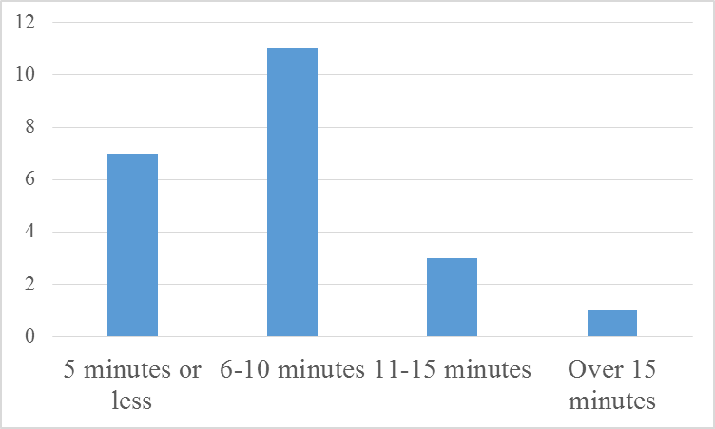
Note. N = 22.

Figure 2
Participant Perception of Survey Length
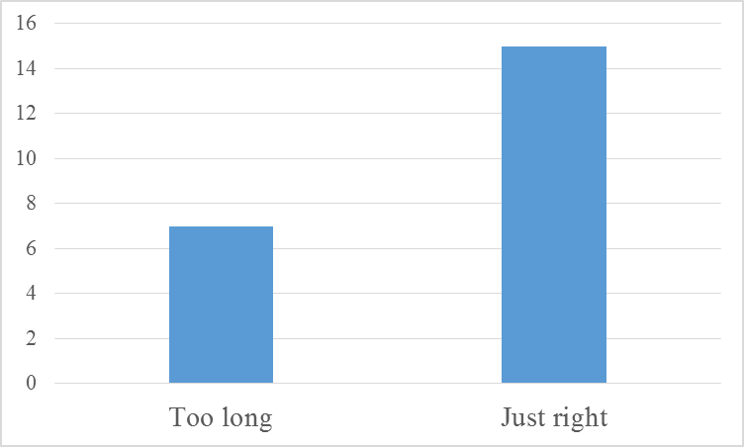
Note. N = 22.

Business friendliness survey. Business friendliness will be assessed using a modified 18-item survey, originated by Allen and Daniels (2013). Survey items include questions such as, “In general, how would you rate [the Niagara Region’s] support of small business owners?”, “Would you encourage or discourage someone from starting a new business in [the Niagara Region]?”, and “How easy or difficult do you think it is to start a business in [the Niagara Region]?” The survey also includes a 6-item scale in which participants are asked to rate a variety of statements in terms of how friendly or unfriendly they think their locale is on a scale from 1 (very unfriendly) to 5 (very friendly). Scale items include topics such as the region’s health and safety regulations, labour and hiring regulations, licensing and fee requirements, and zoning or land use regulations.
Entrepreneurial attractiveness scale. The Niagara Region’s attractiveness to new entrepreneurial talent will be assessed using a 13-item scale created for this study. Previous academic studies have identified top criteria for entrepreneurs when deciding the location of new business locations (e.g. Bluestone, 2013; Cushman & Wakefield, 2011; fDi, 2015; Morris & Brennan, 2003; Reese & Rosenfeld, 2001; Sleutjes & Volker, 2012). Correspondingly, this scale has collected the factors most frequently identified as “essential” by entrepreneurs and asks participants to rate the region on each feature on a scale from 1 (very bad) to 5 (very good). Scale items include factors such as value for money of office space, availability of qualified staff, ease of travelling within the city, transport links with other cities, and access to markets and customers.
Detriments identification checklist. The leading factors that business owners dislike about operating a business in the Niagara Region will be documented using the detriments identification checklist, created for this study. Previous interviews with Canadian business operators have identified several factors that they would most like to see their region take steps to address (City of Victoria, 2013). These factors were assembled into a 12-item checklist to assess the presence of any of these problem areas in the Niagara Region. List items include variables such as poor parking, high taxes, lack of business, too much bureaucracy, and multiple uncoordinated agencies.
Qualitative question. The survey will conclude with the open-ended question, “What do you think the Niagara Region can do to be more business friendly?” Previous versions of the survey included a total of five open-ended questions, but 31.8% of participants complained that the questions made the survey too long, less than 15% of the participants answered all five questions. The four questions that have been omitted in the final survey are the following: “Are you currently experiencing any business challenges? If so, what are they?”, “What information or assistance can you or your employees use?”, “Have you used any business incentives or other assistance offered by the region? If yes, what were they?”, and “What is the Niagara Region doing right to attract and keep businesses?” (questions derived from Davis, Clark, Pesch, Schwartau, & Ryan, 2011).
First three months
Following official approval, the survey should be disseminated to businesses throughout the region via an email address specifically designated for the study. Previous research suggests that as high as 80% of the final participant pool will complete the survey within the first 2 days (Wygant & Lindorf, 1999). More conservative estimates of the time to survey completion indicate that it can take up to 9 days to get the majority of participants to respond (Schaefer & Dillman, 1998).
In keeping with this estimated timeline, the region should be able to begin analysing the data two weeks after releasing the survey. Specifically, data from the survey can be used to give the region an overall letter grade on local business owners’ perceptions of the region’s friendliness towards small businesses, as well as a score of business owners’ overall sentiment towards running a business in the region. For example, the overall small business friendliness score can be determined by combining the scores of the following three related questions: “In general, how would you rate [the Niagara Region’s] support of small business owners?”, “Would you discourage or encourage someone from starting a new business where you live?”, and “How difficult or easy is it to start a business where you live?” The resultant scores can provide the region with an idea of the area’s current strengths and weaknesses. Detailed results of the Niagara Region’s overall “business friendliness” scores can be found in Table 2.

Table 2
The Niagara Region’s Business Friendliness Scores from Pilot Test
Factor | Overall Grade
Overall friendliness | C
Ease of starting a business | D+
Regulations | C
Health and safety | B+
Employment, labour, & hiring | B-
Tax code | C+
Licensing | C+
Environmental | C
Zoning | C+
Training & networking programs | F

The collected survey data may also be used to assess how entrepreneurially friendly the region appears to new talent using the entrepreneurial attractiveness scale. For example, the pilot test suggests that two of the region’s strengths are the availability of qualified staff (63.6% rated the region “very good” or “somewhat good”) and the number of international tourists in the area (72.7% rated the region “very good” or “somewhat good”). The region can use the final collected survey information to understand the strengths of the area to promote to future businesses. Detailed results from this scale can be found in Figure 3.
Finally, the survey data may be used to identify red-flag problem areas in the region using the detriments identification checklist. For example, preliminary data from the pilot test suggests that the region’s problem areas include slow reactions to requests for approval, the region having multiple, uncoordinated agencies, and high taxes. Members of the region may use these results to pinpoint exactly which areas need the most attention in future discussion. The final results of this scale can be found in Table 3.
Figure 3

Example of Preliminary Results to Entrepreneurial Attractiveness Scale
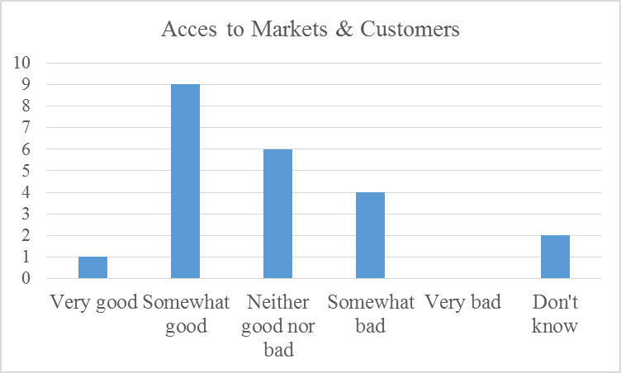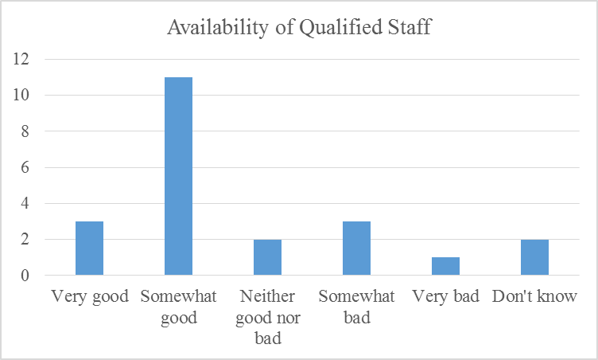
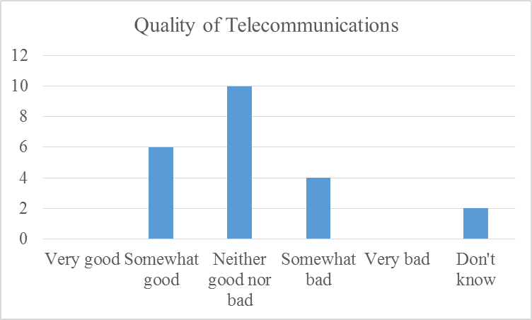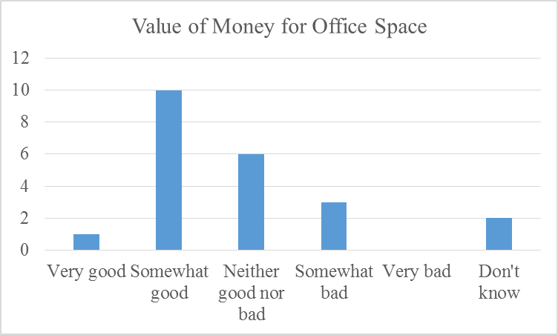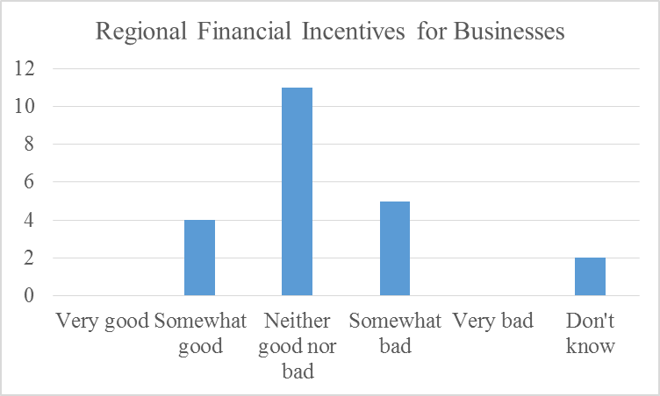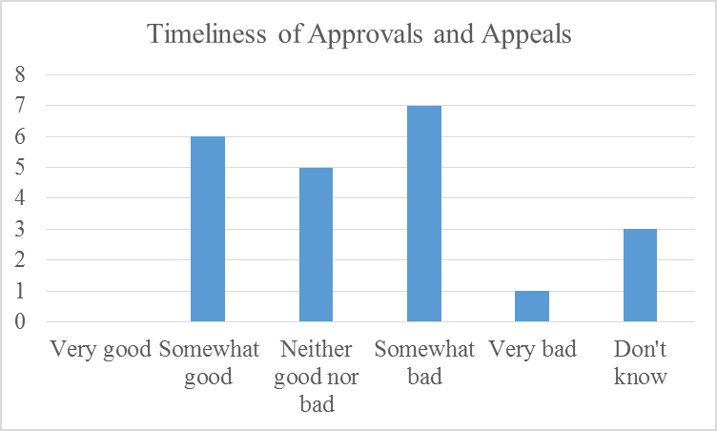
Note: N = 22

Table 3
Preliminary Results of the Detriments Identification Checklist
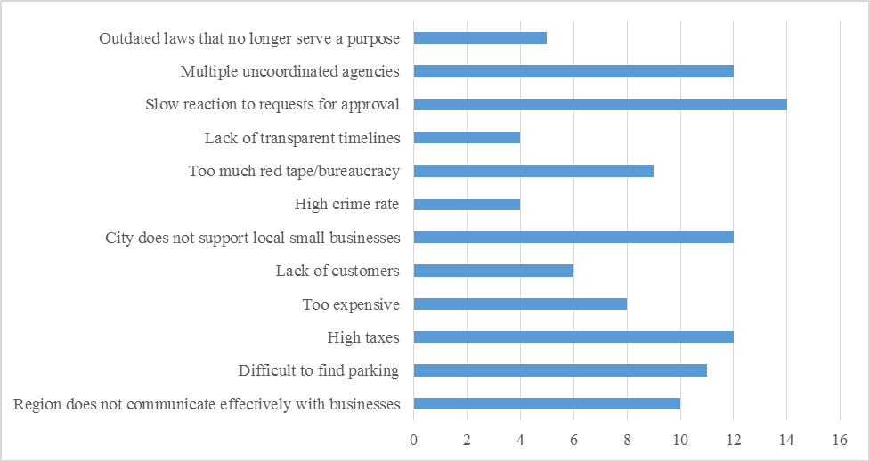
Note: N = 22.

Once the data has been analyzed, members of the region can begin brainstorming ways of overcoming obstacles and working to implement suggestions made by business owners. For example, in the pilot study, 81.82% of respondents indicated that they would like to participate in networking program or training workshops for small businesses run by the Niagara Region, but only 4.5% of the participants were aware that these options were available. In addition, the Niagara Region received an “F” grade for training and networking friendliness. Members of the region may therefore focus some of their efforts on creating or promoting such features.
First year
Within the first year, the Niagara Region should use the information gathered in the surveys to inform their actions and address the most pressing issues. For example, if the final survey data resembles the pilot survey data, within the year, the Niagara Region should have workshops and networking programs for businesses up and running. Other problem areas should also be addressed or there should be concrete plans to address the items. As another example, the region should attempt to speed reaction times, work to integrate their agencies, and lower taxes for small businesses.
If possible, the region should also disseminate the survey again one year after the survey first went out. By having business owners re-do this survey on an annual basis, it will be possible for the region to keep an ongoing concept of where the region is and whether current action plans are working to correct the region’s problem areas.
Contingency plan
Empirical research suggests that if the Niagara Region sends out invitations to complete a survey that are personalized to the business and promise to provide the results of the survey, the response rate should be high (Martin, 1994; Ray, Griggs, & Tabor, 2001). If this is not the case, however, there are a number of things that can be done to increase the individual participation. For example, approximately 36% of surveys that do not receive satisfactory participation numbers ultimately increase their numbers by offering to enter participants in a draw or a raffle as an incentive to complete the study (Comley, 2001). Researchers have also demonstrated that changing the style of the first page of the survey can increase the response rate. Specifically, the length of the first page of the survey can significantly affect the response rate, with overall participation declining 8% for every “page down” it takes for a user to get to the bottom of the first screen (Comley, 2001). In addition, reminder emails may be sent to the businesses that have not responded to the survey once every ten days (to a maximum of three reminders) to increase the response rate.
Conclusion
In conclusion, we believe that the Niagara Region will not be truly "business friendly" until the region has explicitly defined the term. Furthermore, our team believes that the best way for the region to define "business friendly" is by actively reaching out to local business owners and managers for input via an online survey. Through this survey, the Niagara Region’s overall perceived friendliness towards businesses can be operationally defined and given an objective score across a number of characteristics. Ultimately, these scores can be used to direct the Niagara Region’s future efforts and actions towards a friendlier and stronger business environment.

References
Allen, N., & Daniels, D. (2013). Thumbtack.com small business friendliness survey: Methodology and analysis. San Francisco, CA: Thumbtack.
Bluestone, B. (2013). Practical strategies to attract and retain economic investment: Learning from EDSAT. Dunkakis Center for Urban and Regional Policy: Northeastern University.
Boyer, C. N., Adams, D. C., & Lucero, J. (2010). Rural coverage bias in online surveys: Evidence from Oklahoma water managers. Journal of Extension [Online], 48(3) Article 3TOT5. Brown, M. (2014). Canada's best places to live 2014: Time to think small. Money Sense. Retrieved from http://www.moneysense.ca/property/canadas-best-places-to-live-2014-time-to-think-small
Burroughs, G. (2015). Niagara region 2012-2015 council business plan. The Niagara Region. Retrieved from https://www.niagararegion.ca/government/council/2012-2015-cbp-text.aspx
City of Victoria. (2013). City of Victoria 2013 Business Survey. Victoria: Ipsos Reid.
Comley, P. (2000). Pop-up surveys: What works, what doesn’t work, and what will work in the future. Paper presented at the ESOMAR Conference, Edinburg. Paper retrieved from http://www.virtualsurveys.com/papers/paper_9.html
Cushman, D., & Wakefield, B. (2011). European Cities Monitor 2011. London: Cushman & Wakefield.
Davis, G., Clark, J., Pesch, R., Schwartau, B., & Ryan, B. (2011). Surveying business owners. Wisconsin: University of Minnesota Extension.
Dillman, D. A., Smyth, J. D., & Christian, L. M. (2009). Mail and Internet Surveys: The Tailored Design Method, Third edition. New York: John Wiley and Sons.
fDi (2014). European cities and regions of the future 2013/14. fDi Report 2015, 24-42.
fDi (2015). European cities and regions of the future 2014/15. fDi Report 2015, 44-74.
Fitzpatrick, R. (1991). Surveys of patient satisfaction: Designing a questionnaire and conducting a survey. British Medical Journal, 302(6785), 1129-1132.
Industry Canada. (2014). Income and earnings in Niagara. Living in Niagara. Retrieved from http://www.livinginniagarareport.com/economic-development-poverty-prosperity-2014/income-and-earnings-in-niagara-2/
Israel, G. D. (2011). Strategies for obtaining survey responses for extension clients: Exploring the role of e-mail requests. Journal of Extension [Online], 49(3), Article 3FEA7.
Martin, C. L. (1994). The impact of topic interest on mail survey response rate behaviour. Journal of the Market Research Society, 36(4), 327 – 339.
McConnell, J. K., McFarland, C., & Common, B. Supporting entrepreneurs and small businesses. Seattle: National League of Cities Center for Research and Innovation.
Mehta, R., & Sivadas, E. (1995). Comparing response rates and response content in mail versus electronic mail surveys. Journal of the Market Research Society, 37, 429-439.
Morris, R. J., & Brennan, G. P. (2003). Creating a seamless local government and small business interface for better regional economic development outcomes. Journal of Small Business Management, 41(4), 241-254.
Radwanski, A. (2015). Niagara's revitalization is long overdue. The Globe and Mail. Retrieved from http://www.theglobeandmail.com/news/national/niagaras-revitalization-is-long-overdue/article16912183/
Ray, N., Griggs, K., & Tabor, S. (2001). Web based survey research workshop. Retrieved from http://telecomm.boisestate.edu/research/
Reese, L. A., & Rosenfeld, R. A. (2001). Yes, but...: Questioning the conventional wisdom about economic development. Economic Development Quarterly, 15(4), 131-145.
Schaefer, R., & Dillman, D. A. (1998). Development of a standard e-mail methodology: Results of an experiment. Public Opinion Quarterly, 62(3), 378-397.
Schermerhorn, Jr., J. R., & Wright, B. (2014). Management Third Candian Edition. Toronto: John Wiley & Son Canada, Ltd.
Sheatsley, P. (1983). Questionnaire construction and item writing. In P. Rossi, J. Wright, & A. Anderson (Eds.), Handbook of Survey Research (pp. 195-230). New York: Academic Press.
Sleutjes, B., & Volker, B. (2012). The role of the neighbourhood for firm relocation. Tijdschrift voor Economische en Sociale Geografie, 103(2), 240-249.
Wygant, S., & Lindorf, R. (1999). Surveying collegiate net surfers: Web methodology or mythology. Quirk’s Marketing Research Review, 43(4), 441-449.
Appendix A

Business Friendly Survey – Final Draft

Business Friendly Niagara

You are invited to participate in a study which will examine perceptions of the Niagara Region's overall strengths and weaknesses as a business environment.

Please click "continue" if you consent to take part in the study.

Tell us about your business...

Which best describes your position in your business?
Owner and manager
Owner but not manager
Manager but not owner

In which industry do you work?
Agricultural services
Construction
Manufacturing
Professional services
Retail
Other:

How long has your business been operating?
Less than 1 year
1-2 years
3-4 years
5-9 years
10 or more years
How many people does your business employ?
1-5
6-10
11-30
31-50
51-100
100+

Tell us about your perceptions of the current business environment in Niagara...

In general, how would you rate the Niagara Region's support of small business owners?
Very supportive
Somewhat supportive
Neither supportive nor unsupportive
Somewhat unsupportive
Very unsupportive

Would you encourage or discourage someone from starting a new business in the Niagara Region?
Highly encourage
Somewhat encourage
Neither encourage nor discourage
Somewhat discourage
Highly discourage

How easy or difficult do you think it is to start a business in the Niagara Region?
Very easy
Somewhat easy
Neither easy nor difficult
Somewhat difficult
Very difficult

Would you be interested in joining a regional networking program or taking a training workshop for small business owners?
Yes
No

How would you rate your business's financial situation today?
Very good
Somewhat good
Neither good nor bad
Somewhat bad
Very bad

Over the past 12 months, did your company's revenues:
Increase a lot
Increase a little
Stay the same
Decrease a little
Decrease a lot

How has the rate you charge your customers or clients changed over the last 12 months?
Increased a lot
Increased a little
Stayed the same
Decreased a little
Decreased a lot

How do you think your company's financial situation will be 12 months from now?
Substantially better
A little better
The same as today
A little worse
Substantially worse
How would you rate the state of the national economy over the past 12 months?
Very good
Somewhat good
Neither good nor bad
Somewhat bad
Very bad

How would you rate the state of the Niagara Region's economy in comparison to the national economy?
Substantially better
A little better
The same
A little worse
A lot worse

What are your business plans in the next five years?
Expand
Downsize
Close or shut down
None of the above
Don't know

Do you plan on moving or relocating your business out of the Niagara Region within the next five years?
Yes
No
Don't know

How friendly or unfriendly is the Niagara Region with regard to the following types of regulations:
 | Very friendly | Somewhat friendly | Neither friendly nor unfriendly | Somewhat unfriendly | Very unfriendly | Does not apply to my business
Health and safety regulations
Employment, labour, and hiring regulations
Tax code and tax-related regulations
Licensing forms, requirements, and fees
Environmental regulations
Zoning or land use regulations

Tell us more about your perceptions of the business environment in Niagara...

How well does the Niagara Region do in the following aspects:
 | Very good | Somewhat good | Neither good nor bad | Somewhat bad | Very bad | Don't know
Access to markets, customers, or clients
Availability of qualified staff
The quality of telecommunications
Transport links with other cities and internationally
Value for money of office space
Cost of staff
Availability of office space
Regional financial incentives for businesses
Quality of life for employees
Number of international tourists
Ease of getting credit
Availability of business development support services
Value for taxes

Indicate which of the following you think is TRUE of the Niagara Region:
Region does not communicate effectively with businesses
Difficult to find parking
High taxes
Too expensive
Lack of customers
City does not support local small businesses
High crime rate
Too much red tape/bureaucracy
Lack of transparent timelines
Slow reaction to requests for approval
Multiple uncoordinated agencies
Outdated laws that no longer serve a purpose

Tell us more about how the Niagara Region can help your business...

What do you think the Niagara Region can do to become more business friendly?
_______________________________________________________________________________________________________________________________________________________________________________________________________________

Thank you for participating in the study! Your responses have been recorded.

