

**Moving Niagara Forward**

Instructor - Dr. Barry Wright

Course: MBAB 5P04



**Team Members**

Contents

Executive Summary 3

Introduction 3

Problems Facing Niagara 3

Our Proposed Solution 4

Niagara Facts 5

Population 5

Growth rate in Ontario 5

Employed sectors 6

Retirees needs 7

Current savings 7

Savings for well retired life 8

The services retirees want to be offered and the scope for business 8

What Niagara has to offer? 9

Real Estate in Ontario 11

Spreading Awareness 12

Healthcare in Canada 12

Health Care Revenue and Expenses 12

Health Expenditure Summary, by Province/Territory and Canada, 2014 13

Expense forecast 13

Economies of Scale 15

An Example in Florida 15

SWOT Analysis 17

Conclusion 17

Recommendations 17

Action Plan 18

References 19

Appendix 21

# **Executive Summary**

Niagara is facing an issue of stunted growth rates when it comes to its economy and population. Our project aims to combat this stagnation and revive the region. Our vision involves making Niagara a healthcare hub for the Ontario province. This project’s scope revolves around 3 major aspects to make this vision a reality.

The team's first focus was the retirees and the potential economic benefits. Hosting retirees is often viewed in a negative light. Within the realm of possibility, retirees can stimulate an economy by generating jobs to cater for them. Our research shows that retirees' spending decreases due to the removal of work requirements such as owning 4 suits and maintaining 2 cars. However, these retirees still spend the same and quite often even more on leisure activities or renovating their homes and buying cars.

Our second focus covers the profitability of moving into the Niagara region for retirees residing in Ontario. Our research indicated that retirees generally want to retire in their own homes if possible. We believe the low property rates and potential future investments can attract a larger percentage of Canadians. Trading their expensive property for a house at half the cost in Niagara gives their retirement savings a boost, and helps support a more extravagant life style. With the quantitative aspect of moving covered, the qualitative aspect is difficult to account for as it varies significantly from one individual to another. However due to different financial pressures, this option will prove to be viable for a significant number of retirees.

Our third focus explores the possibility of moving into a long term health center due to two reasons:

1. Directly moving into the centers due to financial difficulties.

2. Requiring additional care later in life, after potentially owning a house.

Our methodology in acquiring the research revolves around data acquired from Statistics Canada, and from various other articles and research papers. We later applied the information to project future trends in the Niagara region. This helped us gain a grasp on the potential growth and expenses to be faced.

The project also touched on the effects of economies of scale in concentrating a small percentage of the medical field in Niagara. This paper also discusses what the retirees’ desire and how Niagara can meet their needs.

## **Introduction**

### Problems Facing Niagara

Moving Niagara forward is an initiative that revolves around growing Niagara as a whole, and making it more business friendly. There are several different issues that need to be tackled. New businesses coming into the area view our region as unwelcoming with its “you can’t do that” attitude. The different municipalities each have their own standards which generally overlap and hinder new development initiatives. Everyone in Niagara feels helpless as more and more of the area’s youth are leaving for different parts of Canada and the GTA, when the region wants them to settle in Niagara and cater for and create different businesses in the area. The locals want to create a successful environment for everyone coming to Niagara. They want to see their area grow by stimulating the local economy.

Few of the issues people might face when they attempt to move their businesses here might be:

* It is vague who the figure of authority is, people do not know who to call.
* Very slow implementation of solutions to any problems they face.
* Lack of coordination between development offices leads to unanswered queries for potential investors.
* Expensive fees and taxes stops businesses from making a move.

Our team of MBA students believes that Niagara lacks a flow of constant funding. This translates into heavy unlevied taxes on businesses, which ultimately prevents them from moving here.

An issue Mississauga faces today is the lack of funding. This was caused by heedlessly waiving fees and taxes in an effort to bring more businesses into the area. Mississauga did very well initially. However, the city now faces a deep rooted issue in funding scarcity. Niagara, on the other hand, gives no liberty to businesses when it comes to waiving any tax or fee. This is also one of the major reasons why investors do not see Niagara as a profit making region.

Electricity, although cheaply generated at the falls, can be very expensive for businesses in the region. Some factories can only afford to run from 7 pm to 7 am due to the cheaper usage rates. Although this issue must be resolved. Our team has decided to direct its focus towards other issues.

### Our Proposed Solution

The different regions in Ontario excel at various things, for example, the city of Toronto plays as the headquarters for all the major financial institutions in the country. On the other hand, Waterloo is the center of Information Technology and innovation in Ontario.

Our team believes that the Niagara Region has brimming with potential and unexploited resources. We can see Niagara as the pivotal center for the medical field in Ontario.

With an already strong hospital base, Niagara can easily become one of the top regions in the field of healthcare.

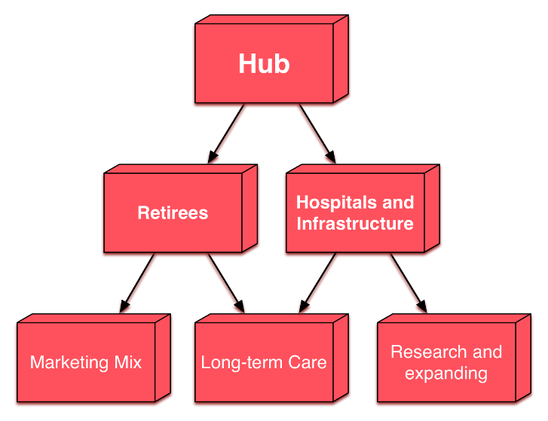

With the issue of healthcare on the table. We’ve separated it into two parts. Retirees focus and other long term care services, and on the other hand, hospitals and patients. This report will focus more on the retirees as a resource and the business they can generate for the area.

# Niagara Facts

## Population

Statistics Canada indicates that we have 5,780,900 senior citizens in Canada, which is 16.12% of the total population. 2,211,152 of this population resides in Ontario, which accounts for 38.25% of our target audience.

Canadian retirees are on the way to outnumber the Canadian youth. The perspective we took from the article is that with waiting lists being so prevalent in retirement housing. An even larger number is expected to flood in and increase the wait time to impossible measures. What if Niagara took the initiative and used that untapped resource - which is often viewed in a negative light - and catered for them. [1]

|  |  |  |  |  |
| --- | --- | --- | --- | --- |
| Population by sex and age group, by province and territory (Number, both sexes) | | | | |
|  | 2015 | | | |
|  | All ages | 0 to 14 | 15 to 64 | 65 and older |
|  | Both sexes (thousands) | | | |
| Canada | **35,851.8** | **5,749.4** | **24,321.5** | **5,780.9** |
| Newfoundland and Labrador | 527.8 | 75.6 | 354.9 | 97.3 |
| Prince Edward Island | 146.4 | 23.3 | 96.0 | 27.2 |
| Nova Scotia | 943.0 | 132.4 | 632.5 | 178.2 |
| New Brunswick | 753.9 | 109.1 | 501.7 | 143.1 |
| Quebec | 8,263.6 | 1,279.0 | 5,532.1 | 1,452.5 |
| Ontario | **13,792.1** | 2,193.0 | 9,387.9 | **2,211.2** |
| Manitoba | 1,293.4 | 240.8 | 860.7 | 191.9 |
| Saskatchewan | 1,133.6 | 215.9 | 751.9 | 165.9 |
| Alberta | 4,196.5 | 770.9 | 2,938.4 | 487.2 |
| British Columbia | 4,683.1 | 682.3 | 3,182.8 | 818.1 |
| Yukon | 37.4 | 6.3 | 27.0 | 4.1 |
| Northwest Territories | 44.1 | 9.4 | 31.6 | 3.0 |
| Nunavut | 36.9 | 11.5 | 24.1 | 1.4 |
| Note: Population on July 1.  Source: Statistics Canada, CANSIM, table [051-0001](http://www5.statcan.gc.ca/cansim/search-recherche?lang=eng&searchTypeByBalue=1&pattern=051-0001&p2=37).  Last modified: 2015-09-29. | | | | |

[2]

## Growth rate in Ontario

According to the census in 2014 St Catharines-Niagara area population is 405,900 and its growth rate compared to 2011 is 0.81% which is the 3rd lowest compared to other major cities in Ontario. London, Ontario has similar population and distance from Toronto when compared against St Catharines-Niagara area buts its growth rate standards at 2.56%.

Complete Population of census metropolitan areas in Ontario can be found in the appendix

[3]

## Employed sectors

The below table describes the different employment sectors in Ontario and Canada. Health care and social assistance is the second largest employment sector after Trade in both Canada and the Ontario province, hence if we are able to bring a significant portion to Niagara area, this would lead to large employment in the area. Health care and social assistance constitutes 11.61% and the other related industries like construction, accommodation and food services that would receive a big boost.

|  |  |  |  |  |
| --- | --- | --- | --- | --- |
| Distribution of employed people, by industry, Canada & Ontario; 2014 | | | | |
|  | **Canada** | **Ont.** | **Industry Contribution in Canada** | **Industry Contribution in Ontario** |
|  | **Thousands** | | | |
| All industries | **17,802.20** | **6,877.90** |  |  |
| Forestry, fishing, mining, quarrying, oil and gas1 | 372.6 | 33.2 | 2.09 | 0.48 |
| Utilities | 136.9 | 51.1 | 0.77 | 0.74 |
| Agriculture | 305.1 | 81.8 | 1.71 | 1.19 |
| Other services | 795.1 | 286.8 | 4.47 | 4.17 |
| Information, culture and recreation | 757.2 | 316.5 | 4.25 | 4.60 |
| Transportation and warehousing | 896.8 | 329 | 5.04 | 4.78 |
| Business, building and other support services2 | 734.8 | 334.7 | 4.13 | 4.87 |
| Public administration | 910.7 | 366.8 | 5.12 | 5.33 |
| Accommodation and food services | 1,207.50 | 450.3 | 6.78 | 6.55 |
| Construction | 1,371.50 | 467.3 | 7.70 | 6.79 |
| Educational services | 1,236.90 | 494.6 | 6.95 | 7.19 |
| Finance, insurance, real estate and leasing | 1,083.80 | 512.1 | 6.09 | 7.45 |
| Professional, scientific and technical services | 1,333.30 | 559.9 | 7.49 | 8.14 |
| Manufacturing | 1,711.00 | 748.6 | 9.61 | 10.88 |
| Health care and social assistance | **2,219.70** | **798.2** | **12.47** | **11.61** |
| Trade | 2,729.30 | 1,047.00 | 15.33 | 15.22 |
| 1. Also referred to as Natural resources. 2. Formerly Management of companies, administrative and other support services. **Source:** Statistics Canada, CANSIM, table [282-0008](http://www5.statcan.gc.ca/cansim/search-recherche?lang=eng&searchTypeByBalue=1&pattern=282-0008&p2=37). Last modified: 2015-01-28. | | | | |

[4]

# Retirees needs

## Current savings

McKinsey & Co. performed a financial survey constituting 12000 households that show 83% of the Canadians are well able to maintain their standard of living even after they stop working. The survey consisted of 9000 working households, and 3000 retired households. The survey shows the advantages of traditional defined benefit (DB) pension plans which allows a guaranteed level of income in retirement showing that 91% percent of mid to high income Canadians with a DB plan are well on track to maintain their previous standard of living.[5]

The survey also demonstrates that the people with Defined Contribution (DC) or group RRSP pension plans will have enough income to maintain equal spending patterns in retirement as before. The survey used for the data assumes the retirees will have similar spending habits in the future and it is highly possible that the future generation of retirees might spend more and have higher income needs as a result.

The process of saving for retirement constitutes of both utilizing RRSP and tax free savings account (TFSA) as well as other types of investment tools. However numbers from statistics indicate that Canadians are saving a minor 4% of their current disposable income despite the huge amount of dollars invested in RRSP and TFSA and therefore have plenty to add to their current retirement basket.[6]

In 2011 the total RRSP investments stands at approximately $34 billion which is a rise from $33 billion in 2010. If an individual who is aged 45 contributes $2000 every year, the amount that the individual will have in his/her RRSP is approximately $75,080 assuming a 5% compound annual growth and 1.5% inflation. And therefore this can be a good estimate of how much money an individual might bring into Niagara in retirement and thus the amount that the individual is able to spent and contribute in the local economy.

## Savings for well retired life

McKinsey & Co. survey shows that most Canadians are able to live comfortably with half of their working incomes and a big portion come from the government pension plans. Therefore most Canadians have the perception that they have plenty to live on even before they have to tap into their retirement saving which will eventually double their spending powers. According to the financial services industry an individual needs to generate 60-70% of their pre-retirement income to have a well retired life. According to one prominent mutual funds company the recommended replacement ratio is preferably 80% as they believe that the retiree will continue spending as much as the individual did while working.

Seniors are able to live on less after retirement mainly because their expenses are less. The seniors have already paid off their mortgages and put their kids through school. And furthermore they no longer have to save for retirement because they have already retired. And their tax bill is less because they no longer have big salaries. Therefore they have money available to spend on things they had planned before retiring.

In average the monthly benefits from Old Age security and CPP is about $ 11200 per person. So a normal working couple is expected to receive about $22,000. If both the individual from the couple worked and contributed to the CPP their whole lives the number can rise as much as $ 32000 a year. Therefore the government money makes a huge difference.[7][8][9]

Ontario is developing its own pension plan to fight the growing retiree problem. This means a more aggressive pension plan is being placed to aid in the increasing numbers of retirees. [10]

## The services retirees want to be offered and the scope for business

There is a huge business to be acquired by concentrating to buyers over the age of 50. Most marketing and business efforts are concentrated on the younger generations whereas the potential buying powers are still with their parents. These people now have a longer life than before thanks to the healthcare improvements over the decade. Their lives are healthier now and they participate in a myriad of events. Therefore these consumers spend a huge sum of money in travel, explore and good healthcare. And there is a huge scope of business in trying to satisfy the needs of this age group, and the businesses that are well positioned to take on this age group and the change of demographics can expect a series of growth and healthy profits. Below are some of the criteria that the baby boomers are looking for

**Ease of access**- An elderly person is not charmed by technology or infrastructure. Seniors require ease of access. The seniors and retirees want products and services that addresses to their changing needs. Products and services that gratify to vision, hearing and dexterity will definitely provide a competitive advantage. Most people would like to retire in their own homes, hence it provides good business possibilities for organizations that make and supply door knobs, easy to use bathroom fixtures, bigger buttons, better lighting, and easier to use storage.

**Cater to their youthful attitudes**- Services that encourage and support an active middle age are very likely to be appreciated by baby boomers. Since most of their basic requirements are met such as owning a home, proper transportation and clothes; they tend to focus from things to experiences. Therefore the businesses that focus on travel, recreation and leisure tailored to the demographics of over 50 is expected to grow. People are living longer than before, and seniors want to make their life count to something. Therefore advertisement campaigns that ridicule their age must be completely avoided.

**Services to maintain independence**- seniors are proud of their ability to live independently. Therefore transportation n services that provide efficient and easier access to hospitals, nearby stores, malls and nearby stores makes their lives easier. Senior friendly communities allow their residents to stay longer in the area, and therefore experience important social interaction with neighbors. There is also a huge scope of business that provide food to their doorsteps.

**Smart Technology**- Safety and comfort are the most important criteria that this demographic wants. High tech equipment are generally safe to use. Profitable services range from technology that reminds them to have their medicines to technologies that provide home alert systems. [11]

# What Niagara has to offer?

**Community Involvement**- Niagara region provides various options for community work for seniors who are interested to take part in social, recreational and civic activities. Niagara's volunteer works provide needed services to the community while keeping the retirees out of expensive hospitals or long term care facilities. The region has many facilities that provide paid and unpaid volunteer opportunities and lifelong learning experiences. This provides an opportunity to the retirees to share their knowledge and wisdom with the community, younger colleagues and with each other. Institutions such as Brock University and Niagara College also provides an excellent opportunity for them to acquire new skills, resources and knowledge. It is estimated that non-profit organizations in Niagara average 60 volunteers per agency and 470 hours a month; equal to 3.12 full time jobs or $131,326 per agency.

**Transportation-** The region provides excellent transportation that have frequent routes to the hospitals, malls, universities and nearby shops. The transportation is cheap, fast, affordable and frequent. Thus provides an excellent opportunity for retirees to travel safer and independently.

**Developed Infrastructure**- Current retirees, seniors, and other residents are already provided with good housing development, healthcare, social activities, and recreational activities. Niagara regions also boasts higher voting rates by seniors than other groups in the population and actively serves on local municipal and other civic bodies. The seniors in Niagara are committed to groups such as Active Living Niagara 50+ that actively pursue their unique needs. Furthermore there are plans to acquire funds to develop an age friendly city initiative in Welland as a pilot project.

**Consumer Focus Health Care services-**

Many seniors and retirees have specific medical needs that go unmet frequently. Over the past year, Niagara Health System has provided specialized healthcare services across the region. Residents of the peninsula had access to a full spectrum of cancer care including radiation therapy through the hospital’s Walker Family Cancer Centre. 7,600 radiation treatments were provided to 700 patients.

Almost 1,300 cardiac care patients were able to receive diagnostic procedures at the Heart Investigation Unit (HIU).

The Mental Health and Addictions Program has started seven new programs, hired 105 new staff members, and recruited seven new psychiatrists with an additional four to join the team in 2014. The availability of new longer-term mental health care has meant that many patients and families no longer have to travel outside the region for care.

The Welland Site opened a Respirology Clinic and has been building a regional Comprehensive General Ambulatory Ophthalmology Program. The program has performed 5,600 cataract surgeries and had 2,200 patient visits.

The Douglas Memorial, Niagara-on-the-Lake, and Fort Erie sites have focused on building improved specialized complex and palliative care services.[12]

**Leisure Activities-** Most retirees want facilities that are near to where they live and that accommodates a variety of needs from the athletic younger senior to the elderly person who may be physically impaired. Niagara Falls Ontario, Canada offers residents and visitors alike a wide variety of recreational activities.

**Library and other services-** The region has many libraries that provide the opportunity to gain knowledge and interact with people. There are also many parks and facilities where people of all ages, income levels and physical abilities can go and have a relaxed time. Families who have children in strollers, who take part in family picnics, who ride their bicycles or run along nature trails are able to access these facilities at a minimal cost.[13]

## Real Estate in Ontario

To follow with the marketing slogan we want to develop, "Retire in your own home". We've decided to run price comparisons between the average priced home in Toronto vs St. Catharines, Niagara-on-the-lake, and Niagara falls.

|  |  |  |  |
| --- | --- | --- | --- |
| City/Province | Price | City | Price |
| Ontario | $471,654 | St. Catharines | $216,503 |
| Toronto | $630,876 | Niagara-on-the-lake | $371,298 |
| Mississauga | $522,804 | Niagara falls | $204,736 |

The table above shows the average prices for houses in the different areas. We have decided to run a price difference test to calculate the amount of instant retirement savings generated when a retiree chooses Niagara for retirement.

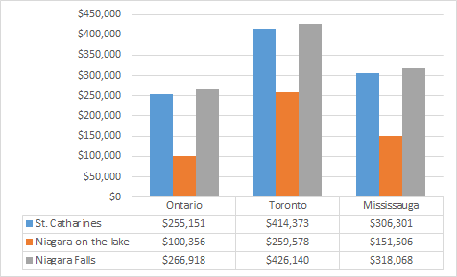

On average, a person selling his house in Toronto can make up to $414 thousand dollars by selling his current home and purchasing one in St. Catharines. If we were to calculate that account with the typical investment interest factor for Canada, a moderate investor would expect a 6% rate of return on his investments according to TD Canada Trust. Calculating the future value of this amount compounded annually for 10 years would grant the retiree investor an additional $328 thousand dollars totaling to $742 thousand dollars.[14][15][16][17]

## Spreading Awareness

Simultaneous to make Niagara an elderly friendly region, a marketing firm should be hired in order to spread awareness regarding the current developments happening in the area. The different municipalities should agree on a marketing campaign that would benefit the Niagara region.

The ad campaign formulated should use all the tools of marketing mix i.e. Product (Niagara), Price (Cost of Living), Place (own home or long term center) and Promotion (senior activity centers, scenic views). The main objective of this process is to reach the maximum number of retirees in shortest possible time. The slogan we want to use, which we believe is our major selling point, "retire in your own home", many retirees and seniors dislike the idea of leaving their homes for the long term care group homes. The prices we are offering, we are giving retirees the chance to settle down without being forced off to a senior group living environment.

# Healthcare in Canada

The healthcare sector in Canada is in a constant state of evolution. The key trends involve accountability, which influences transparency within the system. There is also a large demand for medical services due to the commonness of chronic diseases and the aging population.  The healthcare sector is also affected by consumerism, where patients are demanding for a wider variety of choices when it comes to their treatment, this promotes healthcare to become more personal and innovative. Evidence based medicine is used all the time to collect data on disease and provide protocols in dealing and treating them. Going forward into the future, healthcare catering for all Canadians is surely going to be a challenging task.[18]

## Health Care Revenue and Expenses

As the table clearly shows the maximum expenditure is done by the Ontario province due to its size and population. Ontario government spends over 37% of the entire Canada in which the public sector spends over 68% whereas the rest is covered by the private sector. The ever expanding Ontario region population needs constant health care facilities and the statistics shows that private sector plays a crucial role in it. Niagara region has a lot to offer such as land, personnel etc which is very attractive for private businesses.

## Health Expenditure Summary, by Province/Territory and Canada, 2014

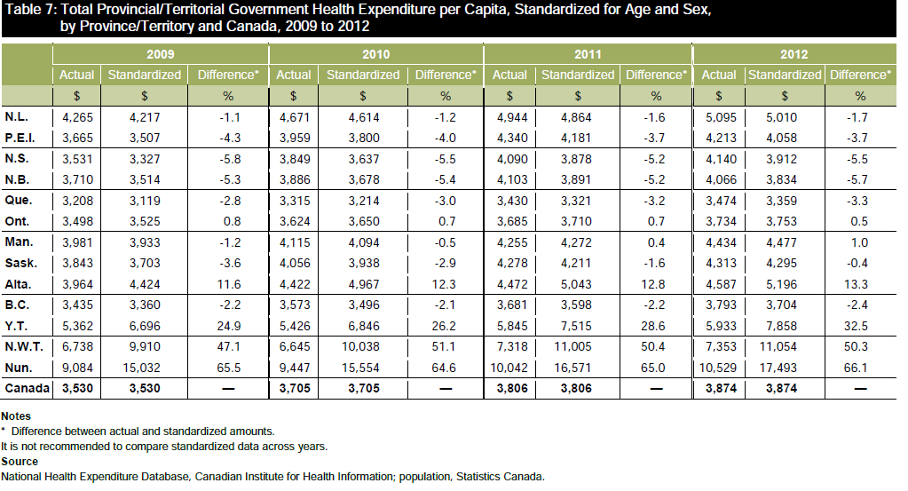

Based on Stats Canada data, during the year starting April 1, 2013 and ending March 31st, 2014, there were 1,519 long-term care facilities in Canada serving 149,488 residents. The long-term care industry generated $10.9 billion, $10.8 billion worth of expenses were also generated alongside the revenues. Regardless of the low profit margin, $7.2 billion of the $10.8 were expensed as wages for employees in those facilities. That is a huge work force that is only expected to get better, with demand being extremely large at the moment. [19]

## Expense forecast

Total health expenditure is expected to amount to $6,105 per Canadian in 2015 and the projections for health spending in Canada could reach $219.1 billion which accounts for 10.9% of Canada’s GDP in 2015.

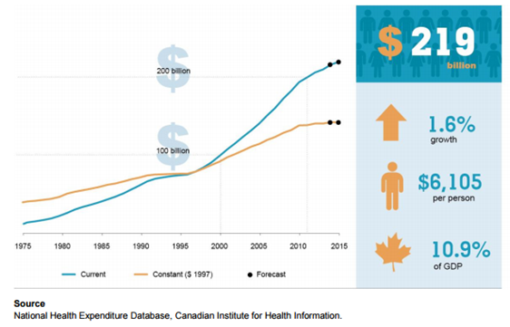

The cost for Canadians 65 and older population is $11,598 in 2013 according to Canadian institute for health information, which is the highest amongst any other age group.[20]

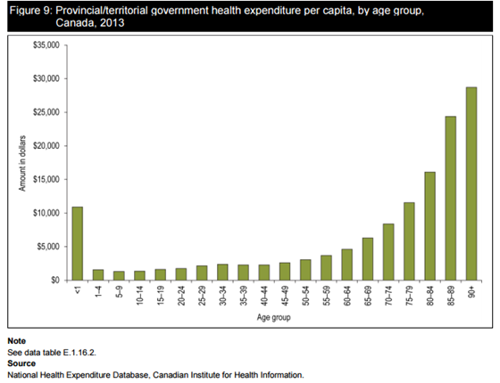

Retiree’s population in Ontario is 2,211,152 and the cost per capita is $11,598, which is equal to $25,644,940,896

2,211,152 x 11,598 = $25,644,940,896

Percentage of Ontario's population over 65 years of age is

2,211,200 /13,792,100 = 0.160323664 ~ 16%

Assuming retiree’s % is constant across Ontario, we have retiree’s population in St Catharines-Niagara area in 2014 as 64,944

405,900 x 0.16 = 64,944

Based on the assumption, expenditure is $753,220,512

64,944 x 11,598 = $753,220,512

Projection of increase in expenditure with increase in retiree’s population in St Catharines-Niagara area

|  |  |  |  |  |
| --- | --- | --- | --- | --- |
| Population | % increase | Population Increase | Cost per capita (Fixed) | Expenditure |
| 64,944 | 0 | 64,944 | 11,598 | 753,220,512 |
| 64,944 | 1 | 65,594 | 11,598 | 760,759,212 |
| 64,944 | 2 | 66,243 | 11,598 | 768,286,314 |
| 64,944 | 3 | 66,893 | 11,598 | 775,825,014 |
| 64,944 | 4 | 67,542 | 11,598 | 783,352,116 |
| 64,944 | 5 | 68,192 | 11,598 | 790,890,816 |
| 64,944 | 6 | 68,841 | 11,598 | 798,417,918 |
| 64,944 | 7 | 69,491 | 11,598 | 805,956,618 |
| 64,944 | 8 | 70,140 | 11,598 | 813,483,720 |
| 64,944 | 9 | 70,789 | 11,598 | 821,010,822 |
| 64,944 | 10 | 71,439 | 11,598 | 828,549,522 |

## Economies of Scale

For the provincial government, the major attraction for the implementation of this paper would be the expense reductions. Based on previous research, we can conclude that economies of scale is positively affected by hospital sizes. If the provincial government were to partially focus some of its medical centers in the Niagara region, productivity would increase leading to a marginal decline in expenses.[21]

# An Example in Florida

Florida's journey in being the home for retirees has not been an easy one. And is currently facing several issues. The state witnesses one of the highest rates for medical fraud, identity thefts, tax regression and other violent crimes. I believe Niagara can learn from Florida's mistakes and avoid them.

On the other hand, Florida faces a problem many other states wish they had. Florida "suffers" from population growth spurts that cause the state to be in a state of confusion. How to cope the extra population without breaking the infrastructure. There is a large need for hospital services that officials worry will be unmet. This further proves Florida's laxness in dealing with these issues.

Florida's population has officially passed the state of New York, to become the 3rd largest state population in the US.[22][23]

Florida's population increase is due to a migration increase as opposed to the natural increase. A natural increase is the positive difference between number of births and deaths. Florida is met with the challenge for not only aging Floridians, but also the aging populations moving in. Florida's population growth is mostly accounted for by people ages 60+, where it is estimated they will account for 56.9% of the population growth from 2010 to 2030.

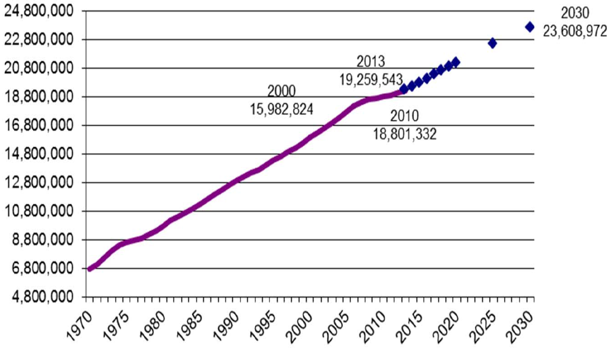

Florida's economy has recently been suffering from a very stagnant growth rate. However, the state is now witnessing a steady growth in its economic sector, which can be accredited to several reasons. Similar to the potential Niagara has, Florida's tourism sector has been booming. 54.1 million Tourists have been reported to have visited the sunshine state in the first half of 2015, which is a record number for just 6 months.[24]

Florida has suffered from a long term unemployment issue, but evidence now shows that firms are now tilting towards hiring, which is helping the economy decrease the effects of this issue.[25]

Florida's natural warm weather and booming economy has successfully attracted the retirees and the next generation of young adults. Our plan for Niagara wants to start by attracting the retirees that will attract the businesses and everyone working under them.

Canada's healthcare system is extremely different to that of the US. Where Canadian health services are funded by the public and done mostly by private hospitals and service providers. We believe this will increase the potential influx to Niagara, or in the worst case scenario, substitute for the warm weather the sunshine state has to offer.

# SWOT Analysis

|  |  |
| --- | --- |
| STRENGTHS | WEAKNESSES |
| * Strong medical base * High percentage of seniors in the region * Highly Skilled Personnel(Brock Medical School) * Research & Development(Cairns Family Health and Bioscience Research Complex) * Recreational Activities (back to nature activities, letterboxing etc.) * Low Property Rates | * Unorganized structure of municipality offices * High utility cost(electricity) * Taxes & Development fees * High transportation cost * Slow response from local government |
| OPPORTUNITIES | **THREATS** |
| * Abundant resources(land, labor, etc) * Wide customer base due to the Falls * Lack of competition in the market * Constantly developing economy | * Environmental constraints * Opposition to change |

# Conclusion

## Recommendations

1. Set a common goal to reduce the bureaucracy across all Niagara area to enhance the quality of services provided by the officials and overall structure of the government department.
2. Hire a marketing firm to construct a marketing campaign focusing on real estate advantages and elderly friendly Niagara in order to reach target population.
3. Systematic changes in the infrastructure of the region such as bigger sign boards, senior activity centers
4. Maintaining the health care related facilities and supporting equipment and services by making use of current health care system such as Cairns Family Health and BioScience Research Complex.
5. Keep track of the progress periodically in order to make sure that suitable changes can be made at appropriate times.
6. Create proper contingency plan regarding the community and social changes prior to the influx of people coming in to the region. Make proper forecasts regarding the economic, population and real estate changes. The region must be developed such that there is a gradual flow of events with proper monitoring on each phase.
7. The seniors are bringing in a significant amount of their savings, and multiple investment tools into the region, therefore it is necessary that experienced personnel and advisors are there to accommodate the procedures.

## Action Plan

|  |  |  |  |
| --- | --- | --- | --- |
|  | Task | Goal | Date |
| 1 | Creating an effective marketing campaign | Reach target population 50,000 (*Media Mix*) | August 2016 |
| 2 | Building required Infrastructure | Retiree friendly region | December 2016 |
| 3 | Feedback from Retirees | Quality check and tracking progression | April 2017 |

# References

(n.d.). Retrieved from Canadian Real Estate Association : http://crea.ca/content/national-average-price-map

Aston, D. (2012, May 8). *How much do you need to retire well?* Retrieved from www.canadianbusiness.com: http://www.canadianbusiness.com/investing/how-much-do-you-need-to-retire-well/

Bernard, D. (2014 , June 27). *How to Profit From Aging Baby Boomers*. Retrieved from http://money.usnews.com: http://money.usnews.com/money/blogs/on-retirement/2014/06/27/how-to-profit-from-aging-baby-boomers

*Distribution of employed people, by industry, by province* . (n.d.). Retrieved from www.statcan.gc.ca: http://www.statcan.gc.ca/tables-tableaux/sum-som/l01/cst01/labor21b-eng.htm

Doug Andrews. (n.d.). *Planning for Retirement: Are Canadians Saving Enough?* CANADIAN INSTITUTE OF ACTUARIES.

*First-year milestones and successes*. (2014, March 24). Retrieved from www.niagarahealth.on.ca: http://www.niagarahealth.on.ca/en/sites-and-services/details/st-catharines

*Florida Passes New York to Become the Nation’s Third Most Populous State, Census Bureau Reports*. (2014 , Dec 23). Retrieved from www.census.gov: http://www.census.gov/newsroom/press-releases/2014/cb14-232.html

Friesen, J. (2013, Feb 18). *Retirees set to outnumber Canada’s youth for the first time*. Retrieved from The Globe and Mail: http://www.theglobeandmail.com/news/national/retirees-set-to-outnumber-canadas-youth-for-the-first-time/article8783751/

*Future Value - FV*. (n.d.). Retrieved from Investopedia, LLC: http://www.investopedia.com/terms/f/futurevalue.asp

Harrington, J. (2014 , June 11). *Florida's economic growth in 2013 better than most of the country*. Retrieved from www.tampabay.com: http://www.tampabay.com/news/business/floridas-economic-growth-in-2013-better-than-most-of-the-country/2183852

Hood, D. (2008, April 14). *Retirement: A number you’ll love*. Retrieved from www.moneysense.ca: http://www.moneysense.ca/retire/retirement-a-number-youll-love/

*How much do you need to save for retirement?* (n.d.). Retrieved from TD Group Financial Services Site : https://tools.td.com/retirement-calculator/

Lamothe, G. (2014, June 24). *Canada: 10 Key Trends in Canada’s Health Sector*. Retrieved from www.mondaq.com: http://www.mondaq.com/canada/x/322472/Healthcare/10+Key+Trends+in+Canadas+Health+Sector

*Long-term Care Facilities Survey, 2013*. (2015, May 04). Retrieved from www.statcan.gc.ca: http://www.statcan.gc.ca/daily-quotidien/150504/dq150504b-eng.htm

Lu, V. (2014, Apr 11 ). *Canadians heading for a retirement income crisis*. Retrieved from Thestar.com: http://www.thestar.com/business/2014/04/11/a_pensioncrisis_primer.html

Masayuki, M. (2010 ). *Economies of Scale and Hospital Productivity: An empirical analysis of medical area level panel data.* RIETI.

McFarland, J. (2015, Feb 10). *Majority of Canadians saving enough for retirement, survey says*. Retrieved from The Globe and Mail: http://www.bnn.ca/News/2015/2/10/Majority-of-Canadians-saving-enough-for-retirement-survey-says.aspx

(2015). *National Health Expenditure Trends, 1975 to 2015.* Canadian Institute for Health Information. Retrieved from https://www.cihi.ca/sites/default/files/document/nhex_trends_narrative_report_2015_en.pdf

*Niagara Falls Recreation Recreational Activities*. (n.d.). Retrieved from www.infoniagara.com: http://www.infoniagara.com/recreation/

*Niagara Region*. (n.d.). Retrieved from www.ontarioimmigration.ca: http://www.ontarioimmigration.ca/en/living/OI_HOW_LIVE_NIAGARA.html

*Population of census metropolitan areas*. (n.d.). Retrieved from www.statcan.gc.ca: http://www.statcan.gc.ca/tables-tableaux/sum-som/l01/cst01/demo05a-eng.htm

*Population with a regular medical doctor, by age group and sex* . (n.d.). Retrieved from http://www.statcan.gc.ca/: http://www.statcan.gc.ca/tables-tableaux/sum-som/l01/cst01/health75b-eng.htm

*Retirement savings in Canada — by the numbers*. (2013 , Jan 04). Retrieved from www.cbc.ca: http://www.tampabay.com/news/business/floridas-economic-growth-in-2013-better-than-most-of-the-country/2183852

Satchell, B. A. (2015, Aug 19). *Record 54.1 million tourists descend on Florida* . Retrieved from www.sun-sentinel.com: http://www.sun-sentinel.com/business/tourism/fl-florida-record-tourism-half-year-20150819-story.html

Zieger, A. (2014, Jan 22). *Florida health system prepares for massive influx* . Retrieved from www.healthcaredive.com: http://www.healthcaredive.com/news/florida-health-system-prepares-for-massive-influx/218321/

## Appendix

#### Growth Rate

|  |  |  |  |  |  |
| --- | --- | --- | --- | --- | --- |
| Population of census metropolitan areas | | | | | |
|  | **2011** | **2012** | **2013** | **2014** | **Growth %**  **2011/2014** |
|  | **persons (thousands)** | | | | |
| Thunder Bay (Ont.) | 125 | 125.1 | 125.2 | 125.1 | 0.079936 |
| Greater Sudbury (Ont.) | 165.3 | 165.5 | 165.7 | 165.7 | 0.2414 |
| St. Catharines-Niagara (Ont.) | **402.6** | **404** | **405.2** | **405.9** | **0.813008** |
| Peterborough (Ont.)1 | 122.2 | 122.7 | 123.1 | 123.3 | 0.892133 |
| Windsor (Ont.) | 328.3 | 330.9 | 332.5 | 333.9 | 1.677149 |
| Kingston (Ont.) | 164.5 | 166 | 167.1 | 168.4 | 2.315914 |
| London (Ont.) | 489.5 | 494.5 | 498.7 | 502.4 | 2.567675 |
| Brantford (Ont.)1 | 139.4 | 140.4 | 141.8 | 143.1 | 2.585604 |
| Kitchener-Cambridge-Waterloo (Ont.) | 493 | 498.9 | 503.1 | 506.9 | 2.742158 |
| Hamilton (Ont.) | 742.5 | 750.7 | 758.3 | 765.2 | 2.966545 |
| Guelph (Ont.)1 | 145.6 | 148 | 149.5 | 150.9 | 3.51226 |
| Barrie (Ont.)1 | 192.8 | 195.4 | 198 | 200.4 | 3.792415 |
| Oshawa (Ont.) | 367.3 | 373.8 | 379.1 | 384.1 | 4.373861 |
| Toronto (Ont.) | 5,769.80 | 5,868.90 | 5,966.30 | 6,055.70 | 4.721172 |
| **Notes:** Population estimates are for July 1st. They are based on 2011 Census counts adjusted for census net under coverage and incompletely enumerated Indian reserves. They are also based on the 2011 Standard Geographical Classification. **Source:** Statistics Canada, CANSIM, table [051-0056](http://www5.statcan.gc.ca/cansim/search-recherche?lang=eng&searchTypeByBalue=1&pattern=051-0056&p2=37). Last modified: 2015-02-11. | | | | | |

1. (Friesen, 2013)
2. (Population with a regular medical doctor, by age group and sex , n.d.)
3. (Population of census metropolitan areas, n.d.)
4. (Distribution of employed people, by industry, by province , n.d.)
5. (McFarland, 2015)
6. (Retirement savings in Canada — by the numbers, 2013 )
7. (Hood, 2008)
8. (Aston, 2012)
9. (Doug Andrews)
10. (Lu, 2014)
11. (Bernard, 2014 )
12. (First-year milestones and successes, 2014)
13. (Niagara Falls Recreation Recreational Activities, n.d.)
14. (How much do you need to save for retirement?, n.d.)
15. (Future Value - FV, n.d.)
16. (Canadian Real Estate Association , n.d.)
17. (Niagara Region, n.d.)
18. (Lamothe, 2014)
19. (Long-term Care Facilities Survey, 2013, 2015)
20. (National Health Expenditure Trends, 1975 to 2015, 2015)
21. (Masayuki, 2010 )
22. (Zieger, 2014)
23. (Florida Passes New York to Become the Nation’s Third Most Populous State, Census Bureau Reports, 2014 )
24. (Satchell, 2015)
25. (Harrington, 2014 )